Zach Tzavelis

ME465 - Sound and Space

03/06/2020

HW5: Exciting Systems

**Question 1**

The purpose of question one was to create functions for generating time-series impulses, simple sine waves, linear sweeping sine waves, logarithmic sweeping sine waves, and random noise on a subset of some interval where the rest of the values are zero. The appendix section marked ‘Question 1’ includes sample plots for these functions. Notably, to generate random noise, a symmetric, flat frequency response was first created using random phase information before converting it back into the time domain.

**Question 2**

Question 2 asked for a comparison of the power spectral density and auto-correlation for each signal type when the sub-signal length (Tp) was changed. Tp lengths of 3s and 6s were selected for a total signal length of 10s. For the sweeping signals, frequencies from 1 to 200 Hz were implemented. For all signals except impulse and random noise, the power spectrum response was generally greater when the Tp was larger —- generally, longer signals have more energy. The impulse signal’s PSD was studied in detail in Figure 1a (the full spectrum is available in the appendix). Increasing Tp had the effect of increasing the variability in the power spectral density response. Since the impulse response excites a wide range of frequencies, it is useful in theory for quickly learning about how a system’s magnitude responds to all frequencies; increasing the Tp may allow for higher frequency granularity when conducting such studies. For the impulse’s auto-correlation, increasing Tp had no effect on the triangular shaped response. Generally, the relatively high AC that impulses have would not make them a good tool for studying how a system delays a signal, nor would increasing Tp provide more information in such studies.

Figure 1a: Impulse

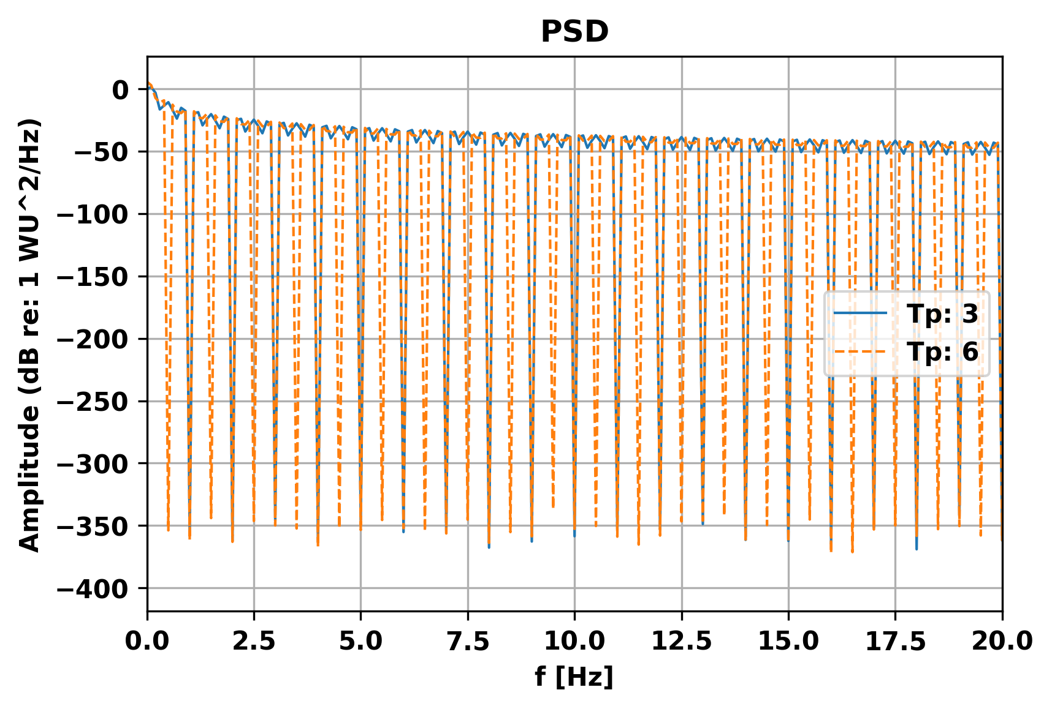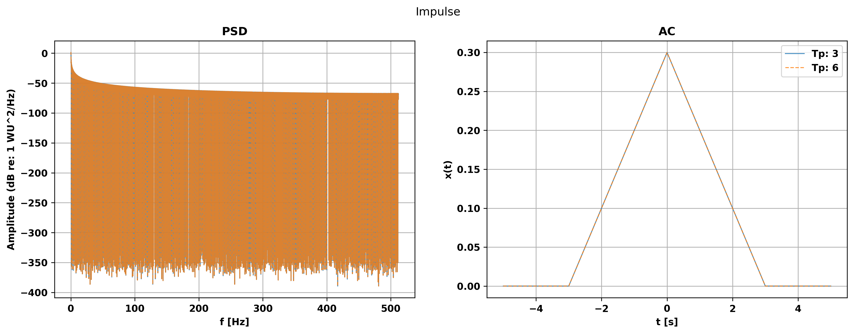

The simple sign wave’s PSD had reduced variability when Tp was increased and the peak frequency had more energy. A simple sign wave may be useful to use when there is a specific reason to study a system’s behavior at a particular frequency; therefore having prior knowledge about the system may be necessary in order to use this tool effectively. Because of the signal’s high auto-correlation, it would not be a good tool for studying the phase delay of a system. The auto-correlation saw increased magnitude when Tp was increased, but this additional information might only make it marginally better at studying the phase delay of a system.

Figure 1b: CW Pulse (f=200 Hz)

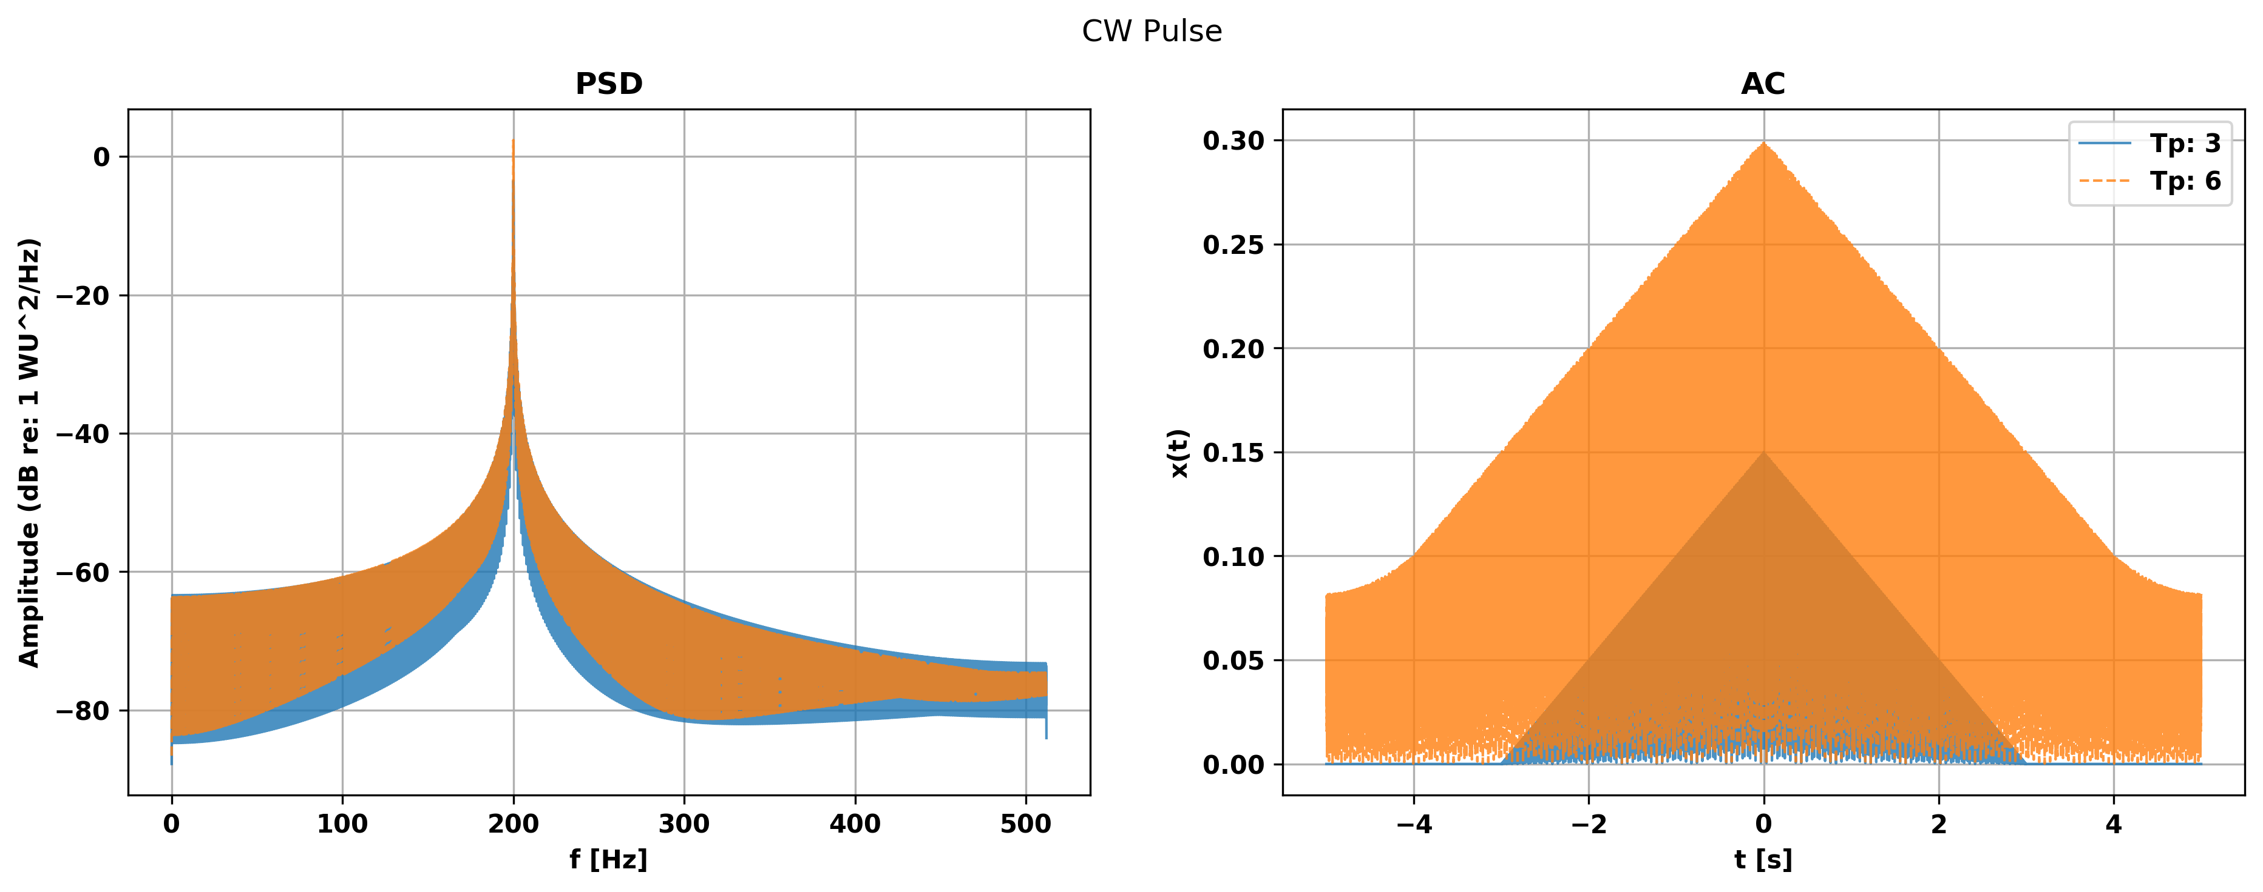

The linear (1c) and logarithmic (2d) sign sweeps had a generally higher PSD and AC when Tp was increased. Notably, the PSD of the linear sweep remained relatively flat in the swept range, while the PSD of logarithmic sweep decreased toward higher frequencies; consequently, it seems like a linear sine sweep would be more useful when studying whether a system amplifies or dampens certain frequencies.

Figure 1c: Linear Sine-Sweep

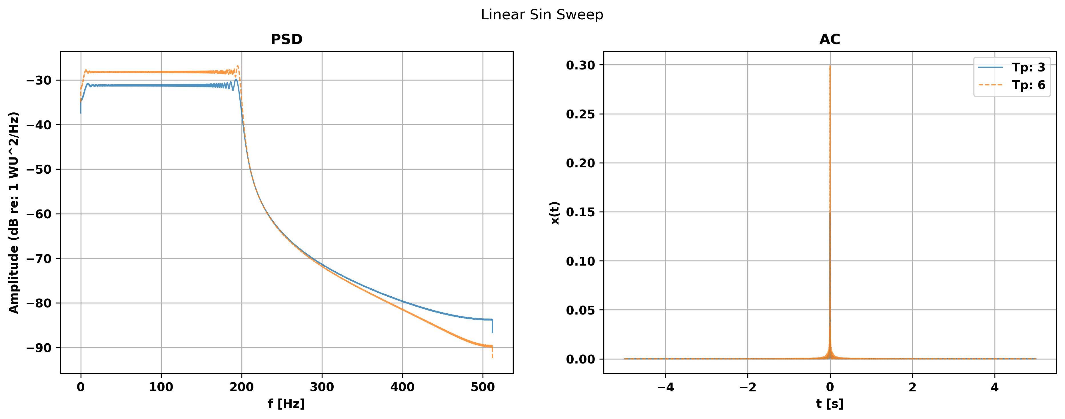

Secondly, the logarithmic sine sweep showed a greater magnitude in its AC across time delays, which would make it slightly harder to study system phase delay. When doing the cross-correlation between an input signal and a measured signal one would ideally like to use an input signal that doesn’t have high auto-correlation — the logarithmic sweep isn’t as ‘bad’ for studying system phase as a simple sign wave however.

Figure 1d: Logarithmic Sine-Sweep

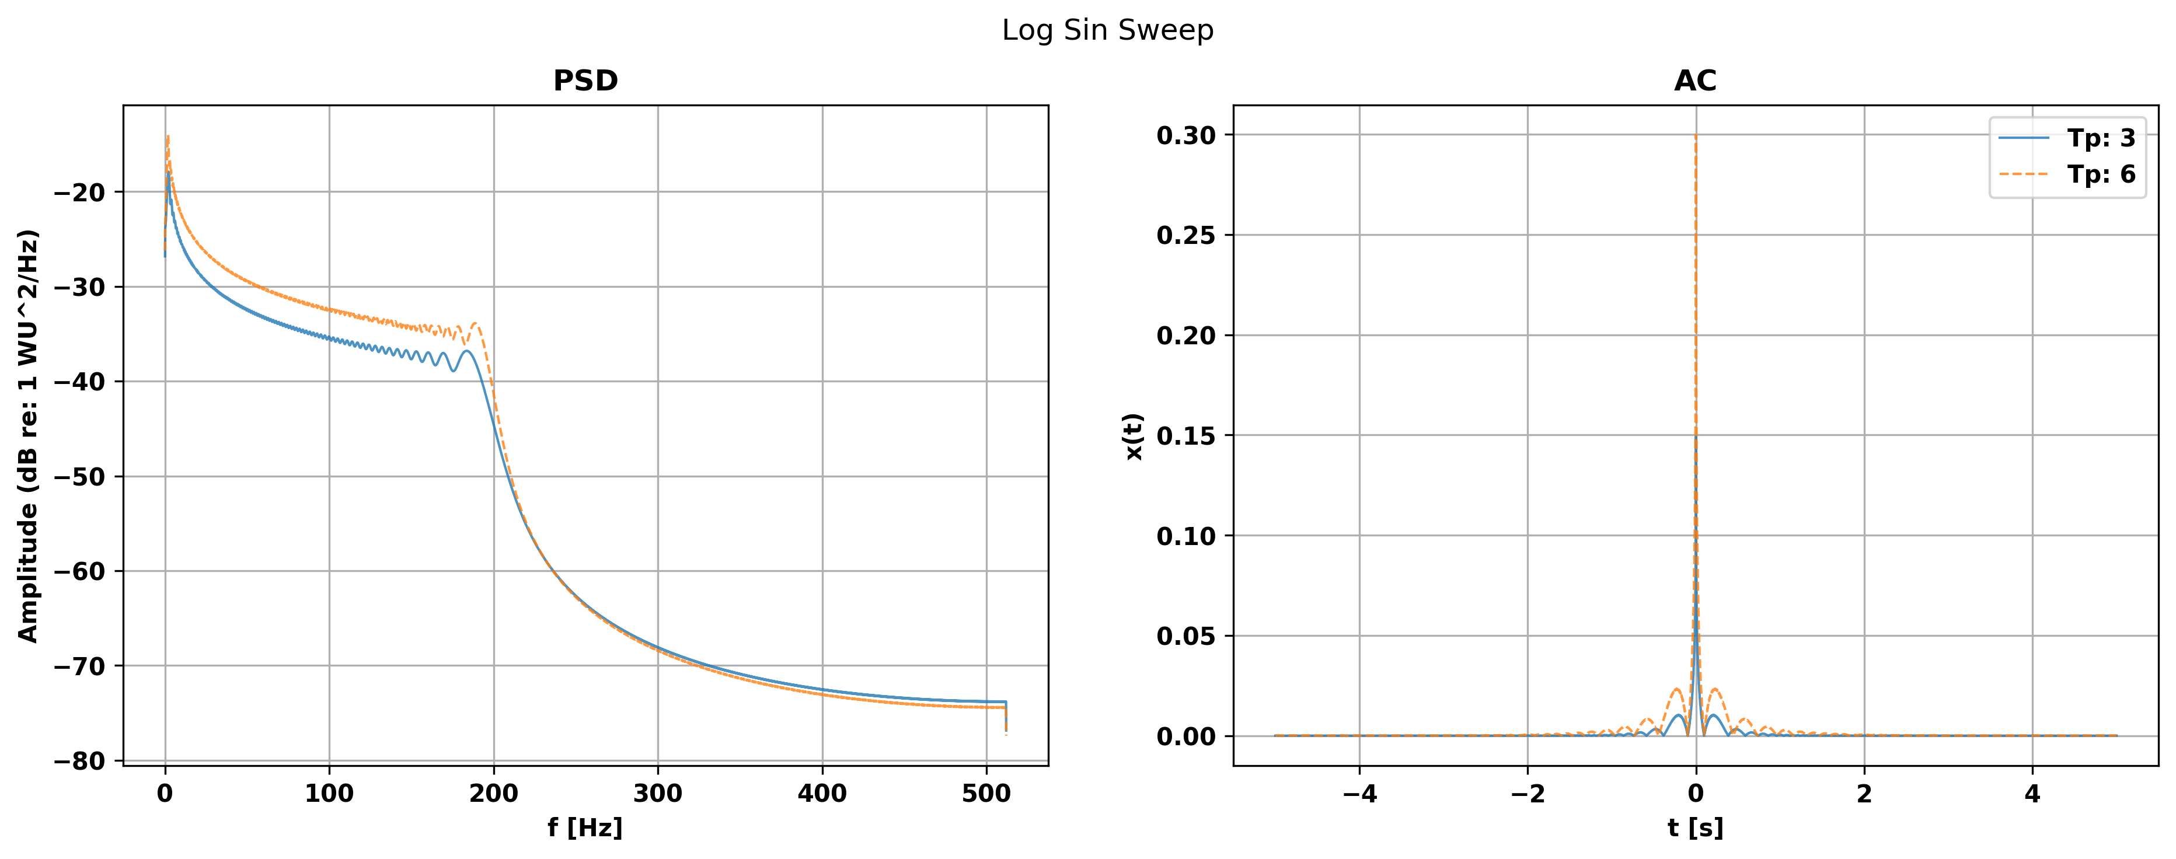

Increasing Tp of the white noise signal seems to increase variability of the PSD response, but likely would not provide a benefit when studying the magnitude of a system’s response. Conversely however, the AC of the noise is fairly low making it a decent tool for studying how a system transforms a signal’s phase (although not as good as the chirps).

Figure 1e: White Noise

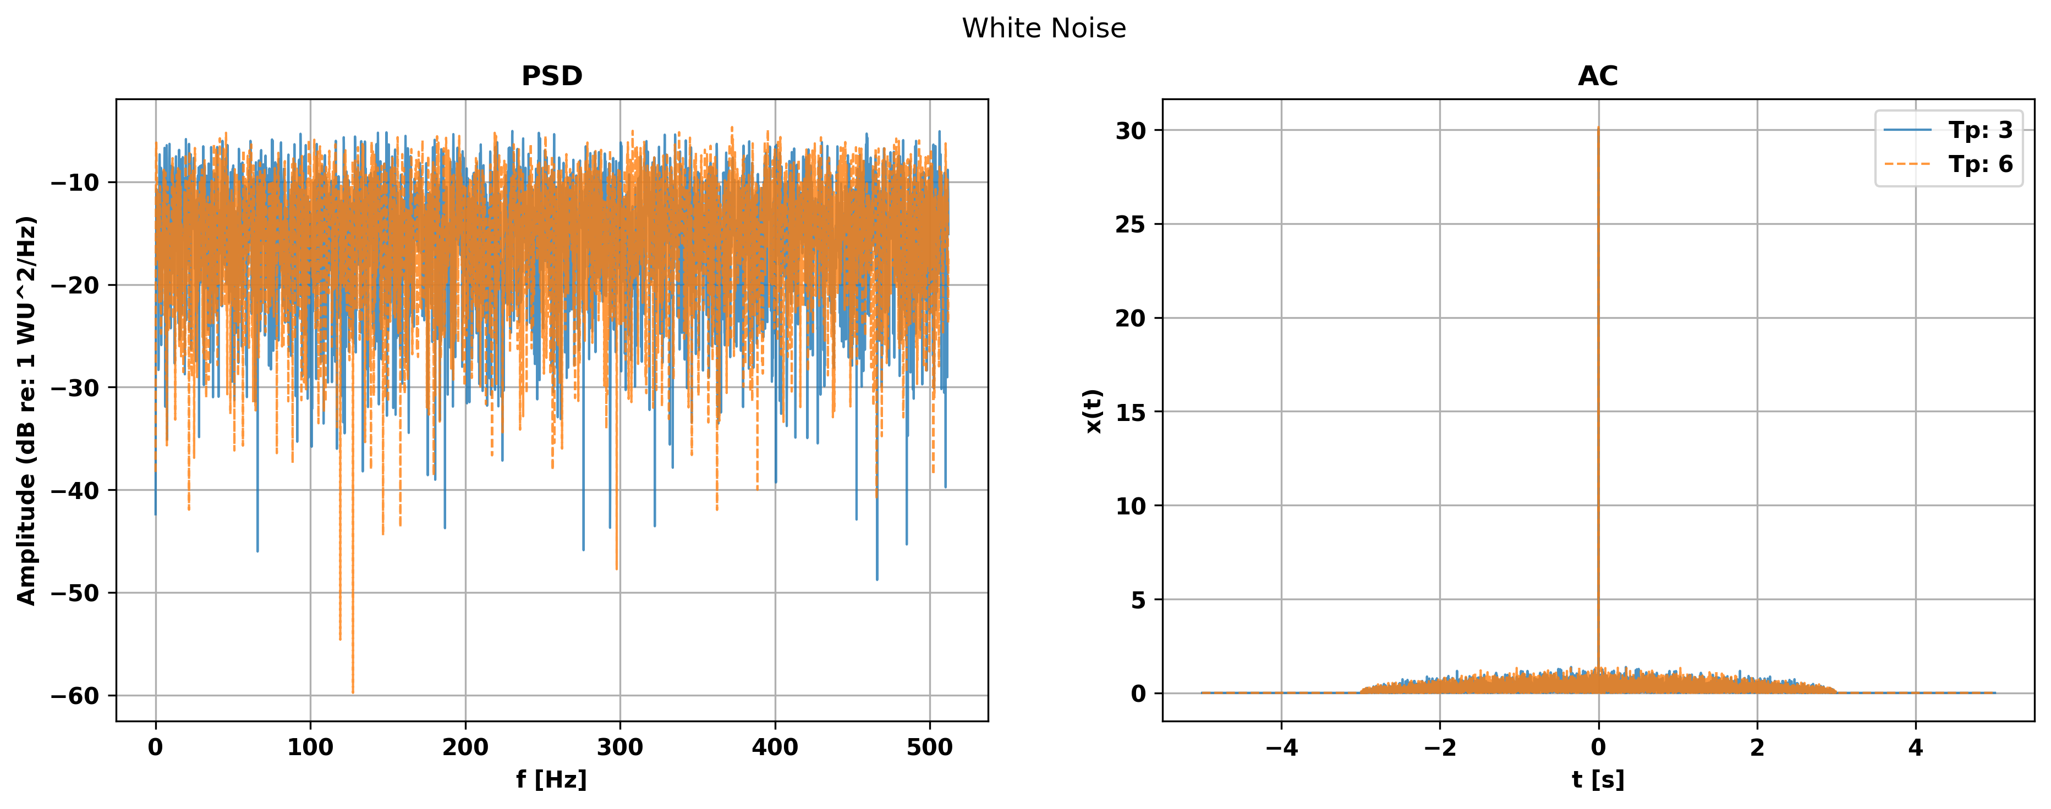

**Question 3**

The purpose of question 3 was to study the impact of a Hann window on the power spectral density (PSD) of a 2000 Hz sine wave. The taper had the effect of reducing the PSD (shift down) and reducing its variability across most of the spectrum (although increased variability at some frequencies). Most importantly however, the taper reduced variability in the PSD near the signal frequency of 2000 Hz, making it easier to identify the signal frequency.

Figure 2: PSD of Sine Wave (f=2000 Hz) with and without Hann Window

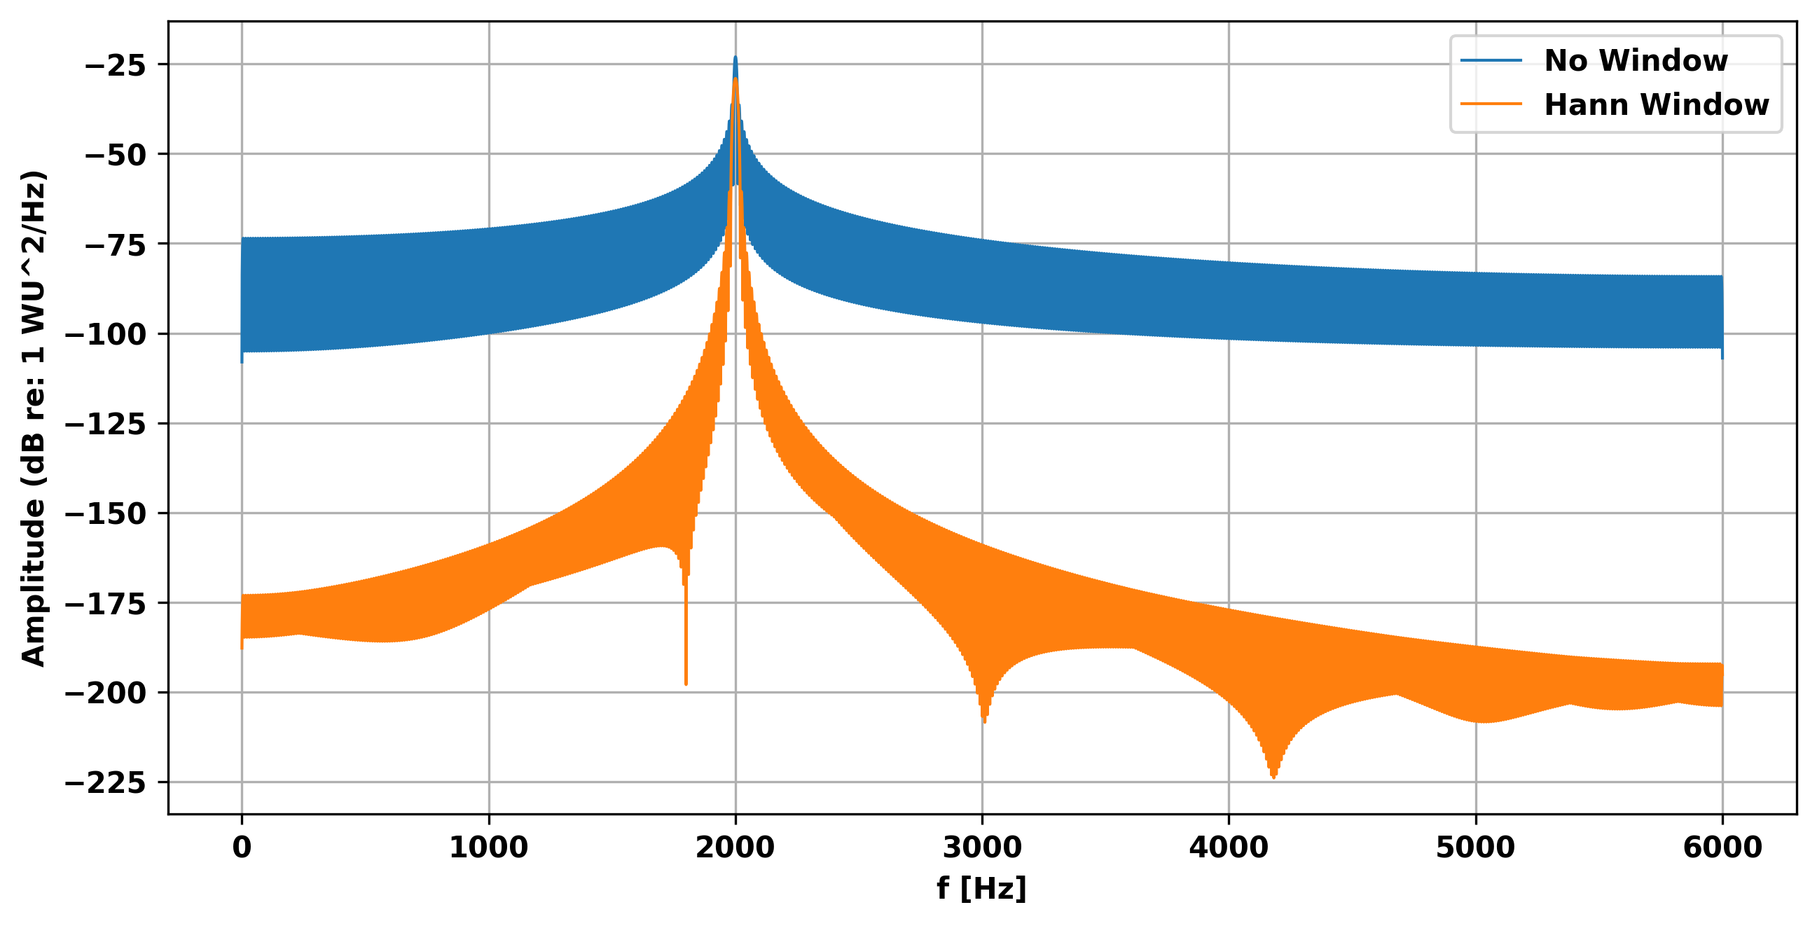

**Question 4**

The purpose of question 4 was to study how a Hann window affects the PSD response of a linear sine sweep. The window seems to have had two effects - it reduces variability but completely changes the shape of the PSD from a relatively flat response to a curve (Figure 3). Increasing the upper range of the chirp to 8000 Hz increases variability of the PSD with and without the window. In the second scenario, the window resulted in a PSD that did not increase and decrease in the same way it did in the first scenario; instead, it reduced variability particularly in the region above 3500 [Hz] and still transformed a relatively flat low frequency range into a smooth ‘increasing’ curve.

Figure 3: Linear Sine Sweep with f2 = 5000 Hz

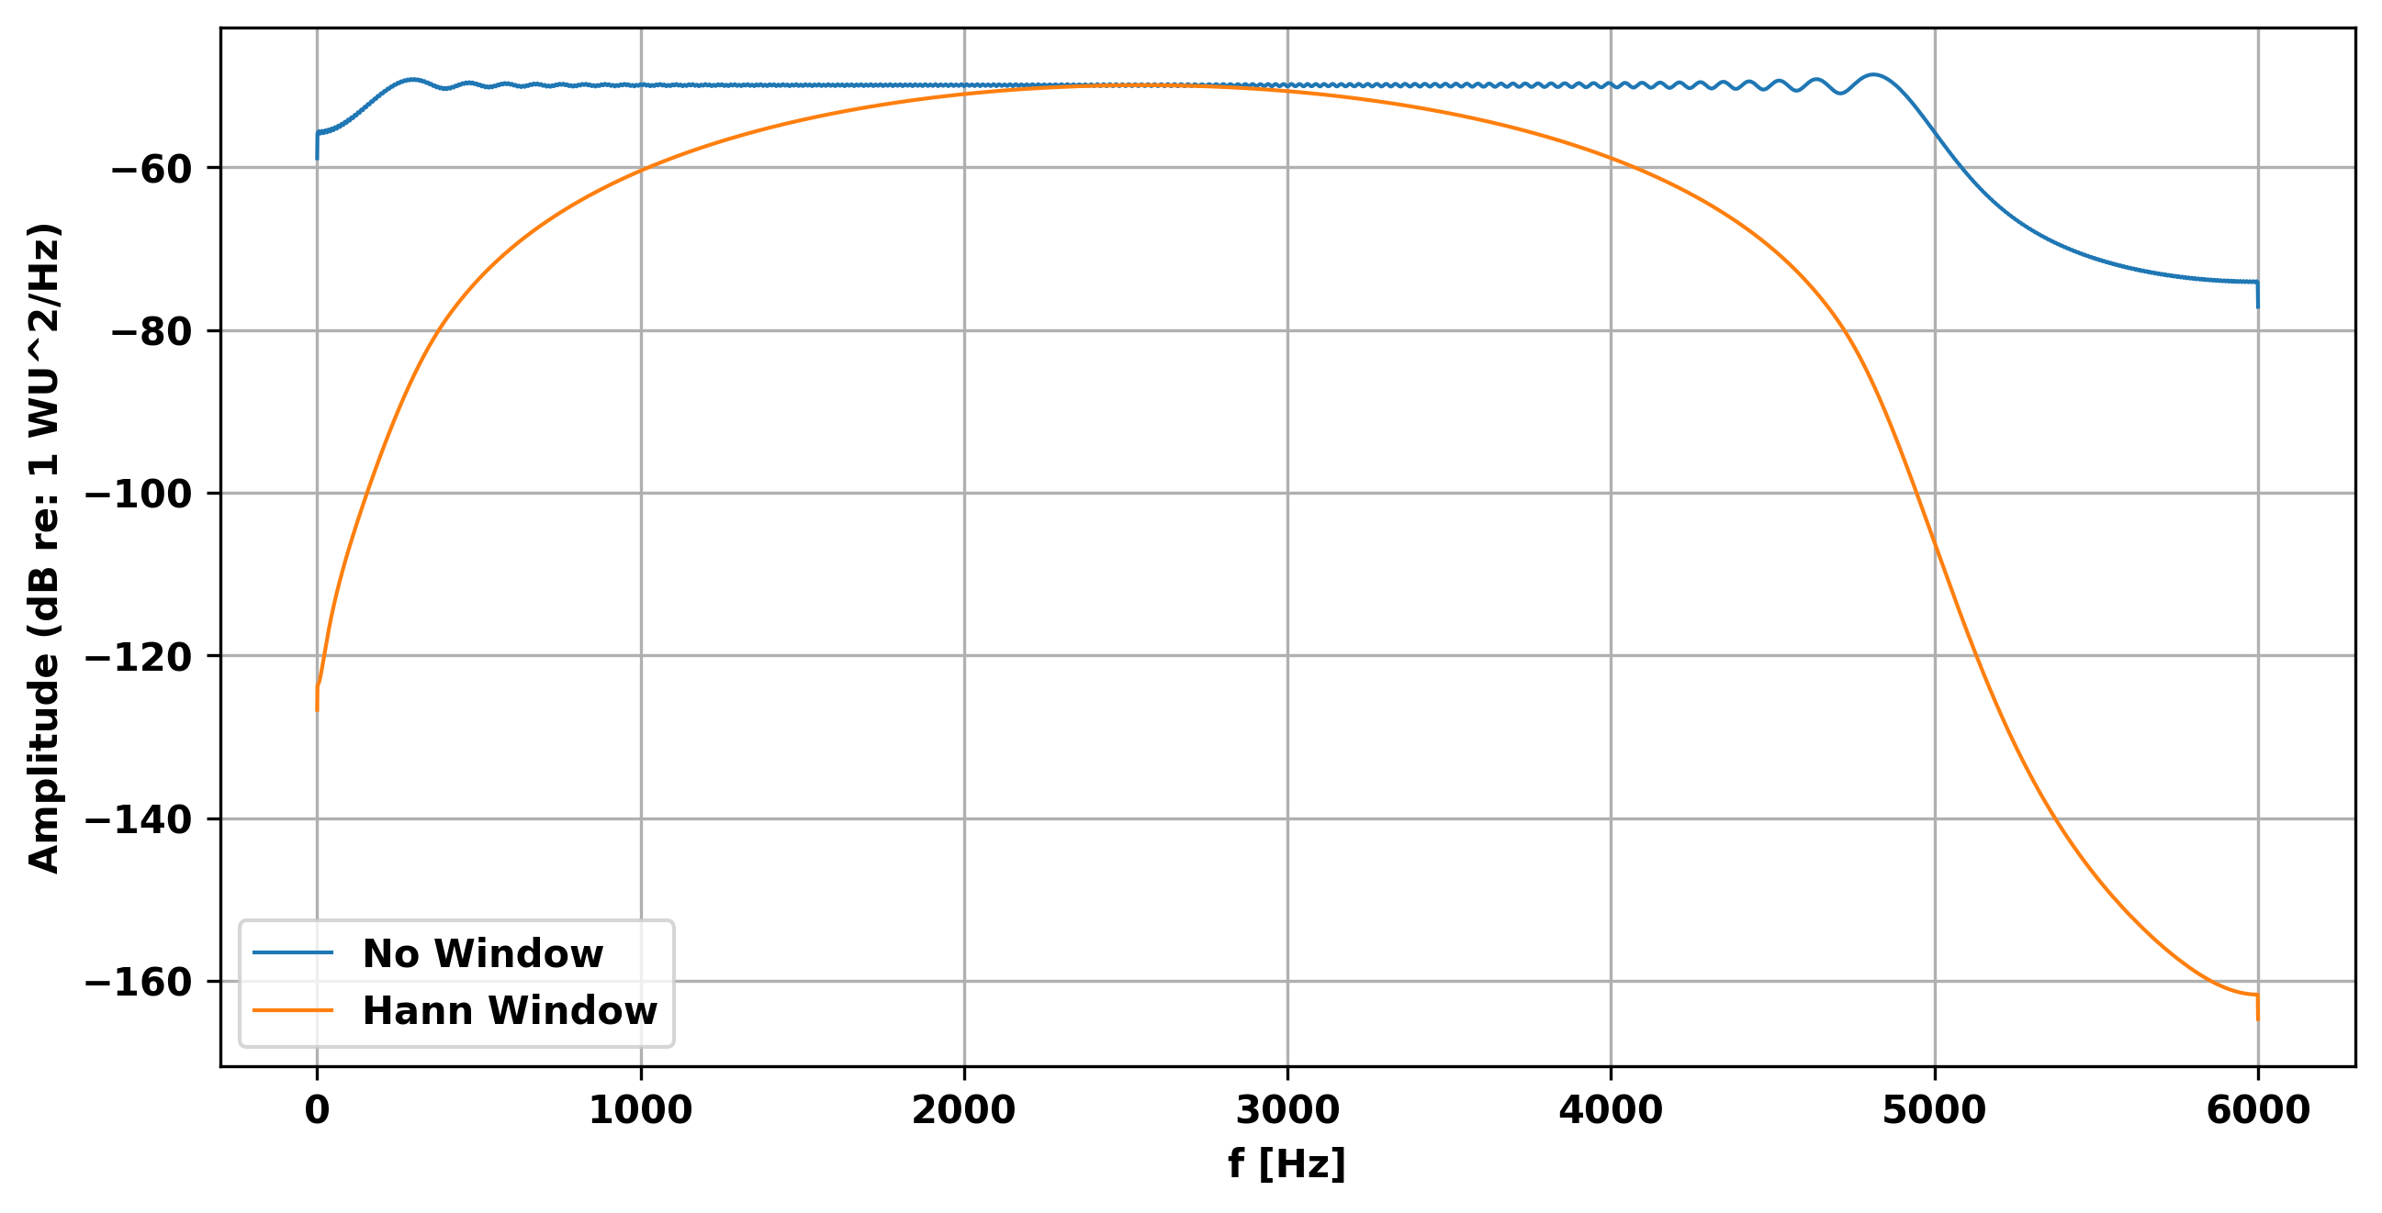

Figure 3: Linear Sine Sweep with f2 = 8000 Hz

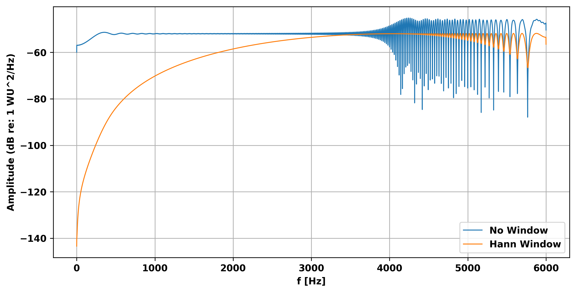

**Concluding Remarks**

The first major take away of the assignment is that one can learn attributes about a system by studying how it responds to a variety of input signals. Some of the input signals are better than others when trying to study particular aspects of a system, depending on whether it is magnitude or phase related information one is after. Generally speaking, a linear sine sweep would be the best to use to learn both phase and magnitude information about the system; however, the PSD at high frequencies can be highly variable. The second major take away is that the use of a Hanning window can help reduce variability in the PSD of a signal, making it easier to analyze a PSD at certain frequencies.